**PNEUMONIA X-ray MACHINE LEARNING MODEL**

**A PROJECT REPORT**

**Submitted by**

Name of students. Exam seat no.

Rupesh Suryawanshi. 20225

Hrushikesh kachgunde. 20226

Prajwal Kulkarni. 20227

Parth Ashtikar. 20228

Pratiksha Giribuva. 20229

Saniya Mulla. 20230

*in partial fulfillment for the award of the degree*

*of*

*Bachelor of engineering*

*in*

**Artificial intelligence and data science**



**DR. D Y PATIL INSTITUTE OF ENGINEERING, MANAGEMENT AND RESEARCH**

**SAVITRIBAI PHULE PUNE UNIVERSITY, PUNE**

**2020-21**

**CERTIFICATE**

**This is to certify that the following students have satisfactorily carried out the First Year Engineering Project Based Learning project work entitled "PNEUMONIA DETECTOR "**

**This work is being submitted for the Project base learning Subject work completion of First Year Engineering. It is submitted in the partial fulfilment of the prescribed syllabus of Savitribai Phule Pune University, Pune for the academic year 2020-21.**

|  |  |  |
| --- | --- | --- |
| **Guide** | **<< Name>>**  **Head of the Department** | **Dr. Mrs. A.V.Patil**  **Principal** |

**DEPARTMENT OF FIRST YEAR ENGINEERING**

**DR. D Y PATIL INSTITUTE OF ENGINEERING, MANAGEMENT AND RESEARCH**

**SAVITRIBAI PHULE**

**PUNE UNIVERSITY**

ii

**ACKNOWLEDGEMENT**

I would like to express my special thanks of gratitude to my project guide **ROHIDAS MALI SIR** as well as our principal **Dr. Mrs. A.V.Patil** who gave me the golden opportunity to do this wonderful project on the topic **PNEUMONIA DETECTOR**, which also helped me in doing a lot of research and i came to know about so many new things I am really thankful to them.

Secondly, I would also like to thank my parents and friends who helped me a lot in finalizing this project within the limited time frames.

**Students Name**

RUPESH SURYAWANSHI (20225)

HRUSHIKESH KACHGUNDE (20226)

PRAJWAL KULKARNI (20227)

PARTH ASHTIKAR (20228)

PRATIKSHA GIRIBUVA (20229)

SANIYA MULLA (20230)

|  |  |
| --- | --- |
| Date : |  |
| Place : |  |
|  |  |

iii

**TABLE OF CONTENTS**

|  |  |  |
| --- | --- | --- |
|  | **TITLE** |  |
|  | **ABSTRACT** | **iii** |
|  | **LIST OF TABLES** | **v** |
|  | **LIST OF FIGURES** | **vi** |
|  | **LIST OF SYMBOLS AND ABBREVIATIONS** | **vii** |
| **1.0** | **INTRODUCTION** | **1** |
|  | 1.1 introduction | 1 |
|  | 1.2 Problem statement | 1 |
| **2.0** | **METHODOLOGY** |  |
| **3.0** | **EXPRIMENTION** |  |
| **4.0** | **RESULT AND SOLUTIONS** |  |
| **5.0** | **RESOURCES** | **3** |
|  |  | 3 |
|  |  | 3 |
|  |  | **4** |
|  |  | 4 |
|  |  | 4 |
|  |  | **5** |
|  |  | 5 |
|  |  | 5 |
|  |  | **6** |
|  |  | **7** |
|  |  | **8** |

**ABSTRACT**

**This study proposes a convolutional neural network model trained from scratch to classify and detect the presence of pneumonia from a collection of chest X-ray image samples. Unlike other methods that rely solely on transfer learning approaches or traditional handcrafted techniques to achieve a remarkable classification performance, we constructed a convolutional neural network model from scratch to extract features from a given chest X-ray image and classify it to determine if a person is infected with pneumonia. This model could help mitigate the reliability and interpretability challenges often faced when dealing with medical imagery. Unlike other deep learning classification tasks with sufficient image repository, it is difficult to obtain a large amount of pneumonia dataset for this classification task; therefore, we deployed several data augmentation algorithms to improve the validation and classification accuracy of the CNN model and achieved remarkable validation accuracy.**

vi

**LIST OF TABLES**

|  |  |  |
| --- | --- | --- |
| **Table No.** | **Title** | **Page No.** |
| Table 1.1 | Name of the table | 1 |
| Table 2.1 | Name of the table | 2 |
| Table 3.1 | Name of the table | 3 |

vi

**LIST OF FIGURES**

|  |  |  |
| --- | --- | --- |
| **Figure No.** | **Title** | **Page No**. |
| Figure 1.1 | Name of the figure | 1 |
| Figure 1.1 | Name of the figure | 2 |
| Figure 1.1 | Name of the figure | 3 |

viii

**LIST OF SYMBOLS AND ABBREVIATIONS**

|  |  |
| --- | --- |
| **Symbol** | **Explanation** |
| $ | Dollar |
|  |  |

ix

1. **INTRODUCTION**

**There are a lot of diseases due to which many people die. One of the leading causes of deaths is Pneumonia. Worldwide more than 450 Million people get infected with pneumonia and that results in around 4 Million Deaths. The amount of deaths due to pneumonia is decreasing year on year due to increase in vaccines for certain types of pneumonia, increase in antibiotics and drugs in general. However the death count still remains significant.**

**While treating Pneumonia, time is crucial. One of the major problem doctor’s encounter during diagnosis of pneumonia is identifying the type of pneumonia. The problem exists because there are a lot of reasons of which Pneumonia is a symptom of like for instance infection due to bacteria, fungus and viruses which also include the SARS-COV 2 which is responsible for Covid 19. Diagnosis depends upon the cause. Traditionally what doctors do is get the X-ray of the patient’s lungs then try to determine the cause with the help of it. If they fail to do that, they would ask the patient for more time consuming and expensive tests like microbial culture and sputum.**

**So it would be quite useful if there was a fast, inexpensive and reliable method to determine the type of pneumonia. This is exactly what we, the students at DYPIEMR are trying to do. We have developed machine learning model for classification of pneumonia based only on X-RAY scan of the lungs. The scan would be analysed by this model and it would return the result as what type of pneumonia it is. It has __ACCURACY__ accuracy in determination of type of pneumonia due to which it is reliable and very fast. It would reduce the time for diagnosis and save lives from life threatening types of Pneumonia. It would lessen the expenses of diagnosis. In case the pneumonia is untreatable and spreads with contact, this would help to isolate the patients immediately so that it doesn’t spread to a lot of people.**

**PROLBEM STATEMENT:**

**TIME :**

Time is crucial in identifying type of pneumonia

**FINANCIAL:**

Expensive medical test cost like microbial culture and sputum.

**DEATH COUNT :**

The amount of deaths due to pneumonia is deacreasing year on year. however the death count still remains significant.

**CAUSE:**

Take the chest x-ray of the patient's then try to determine the cause.

**DIAGNOSIS:**

One of the major problem doctor's encounter during diagnosis of pneumonia is identifying the type of pneumonia.

Table 3.1 : Title of the table

**2.METHODOLOGY**

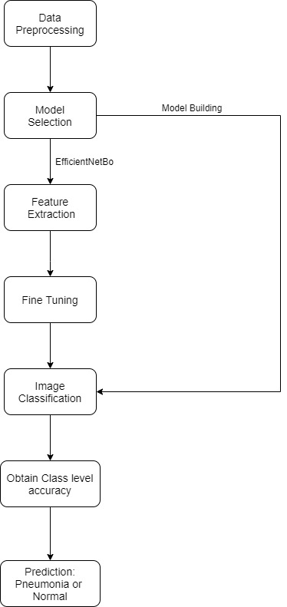

7

1. **EXPERIMENTATION**

For this model we have build our on model as well as use efficint NETBO.

High accuracy achieved by efficient NETBO.

Scaling up with fine tuning to better suit the problem using softmax activation to get the prediciton probabilities of each class.

Efficient Net can be considered a group of convolutional neural network models

The efficient Net model group consists of 8 models from bo to b7 with each subsequent model number referring to variants with more parameters and higher accuracy.

1. **RESULT AND SOLUTIONS**

**FASTERS RESULTS**

**Faster result help reduce importanat time for patients health.**

**Accuracy**

**It has accuracy over 90% which is enough to get clinically approved.**

**Cost effective**

**Less cost means everybody can access it at minimal or no cost at all.**

**Resources :**

The data for the chest x-rays for this project was provided by MENDELEY.COM .